Recruiting Portal Changes after Update to RU 39

These are the steps to follow.
1 - Go to Portal Management App
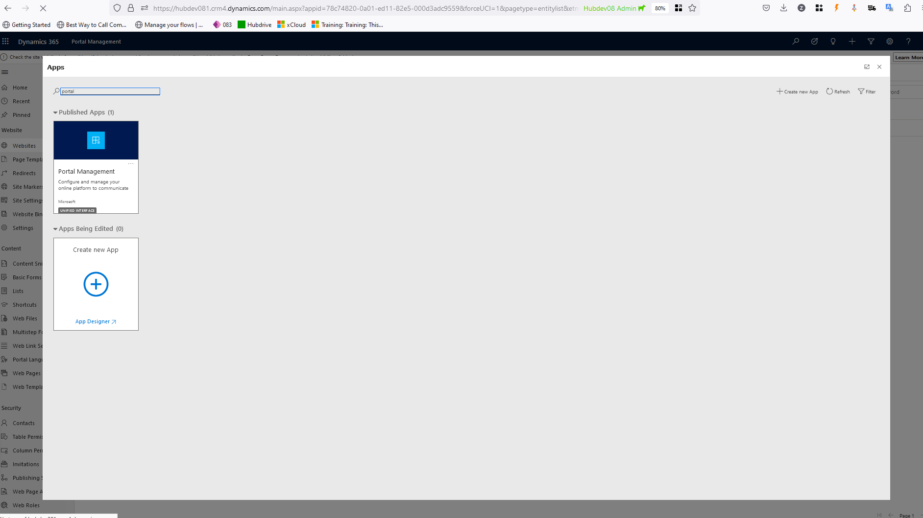

2 - Go to Multipstep Forms from the left side navigation Menu and open the "Vacancy Details and Application Process (xRM1 Web Form)"
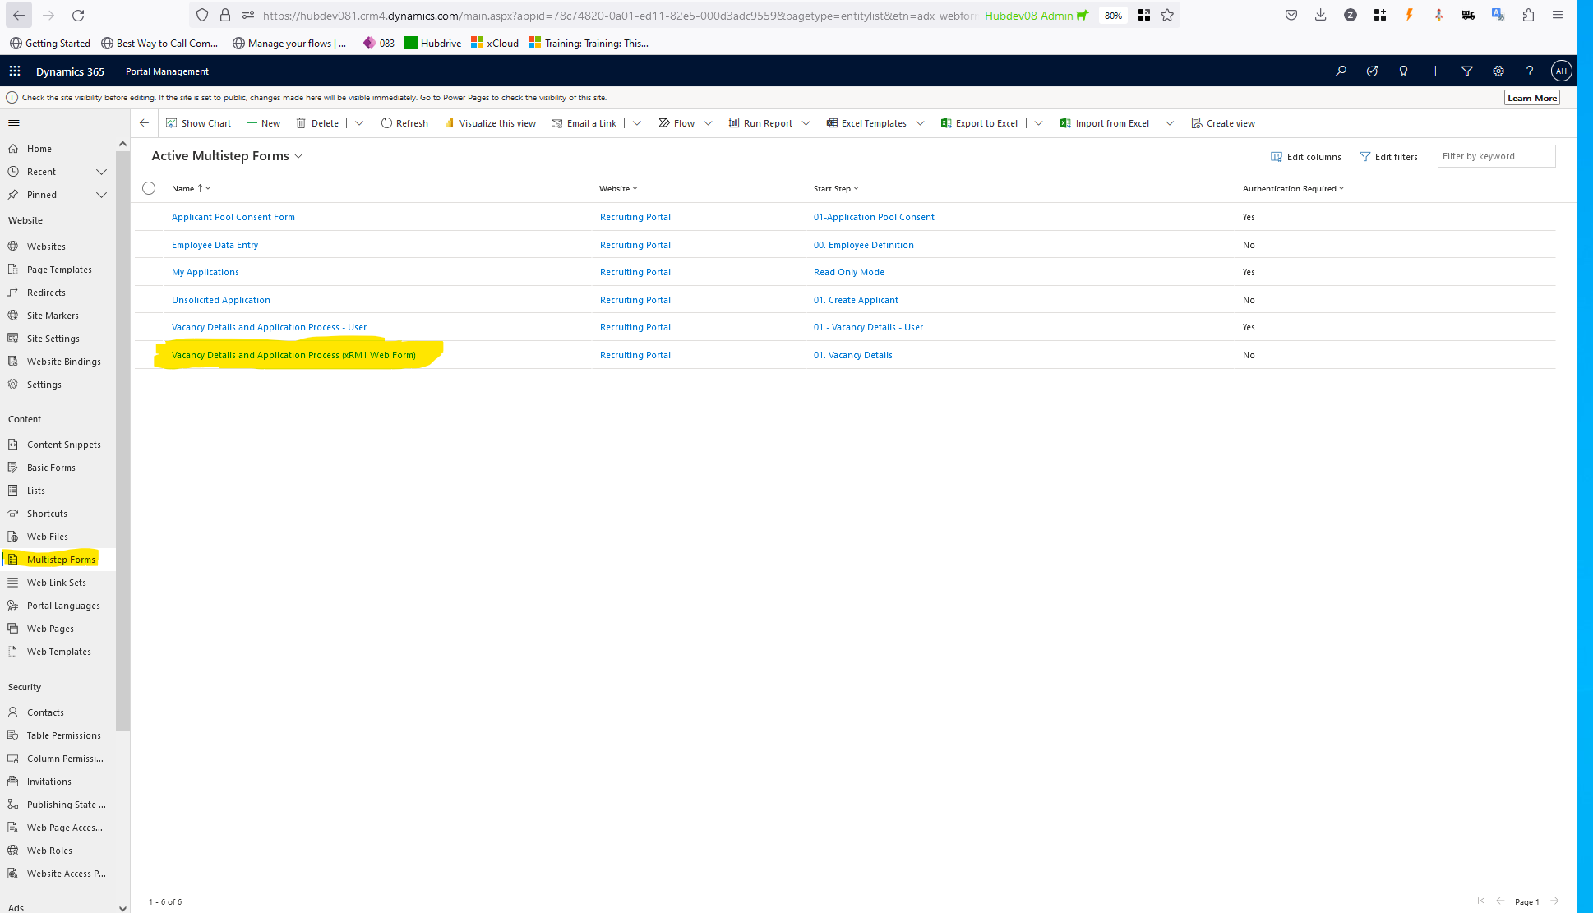
3 - Then Click "Form Steps" tab, then open "Vacancy Details and Application Process" having Name "01. Vacancy Details"
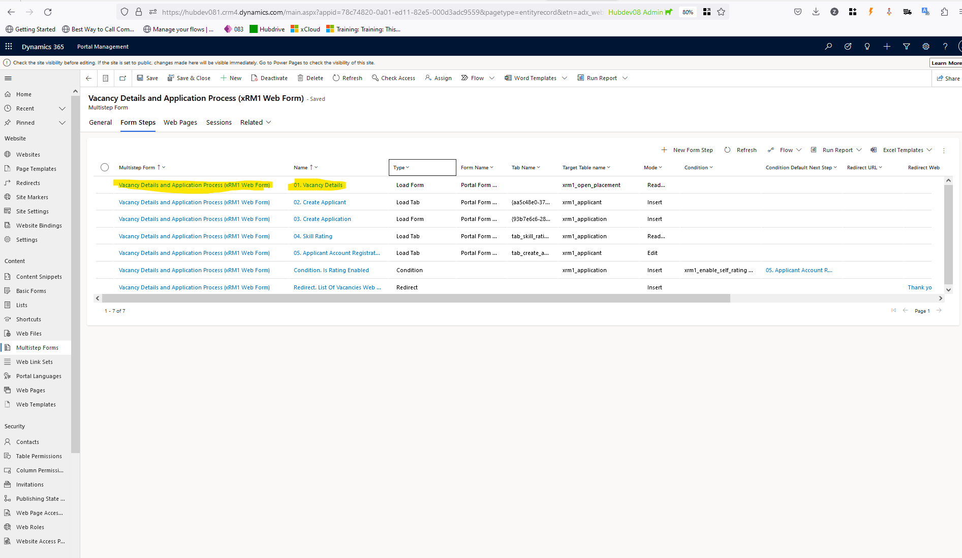

4 - Then Go to "meta data" from (if not visible in tabs by default click Related tabs) in Vacancy Details and click "New Multistep Form Meta Data"
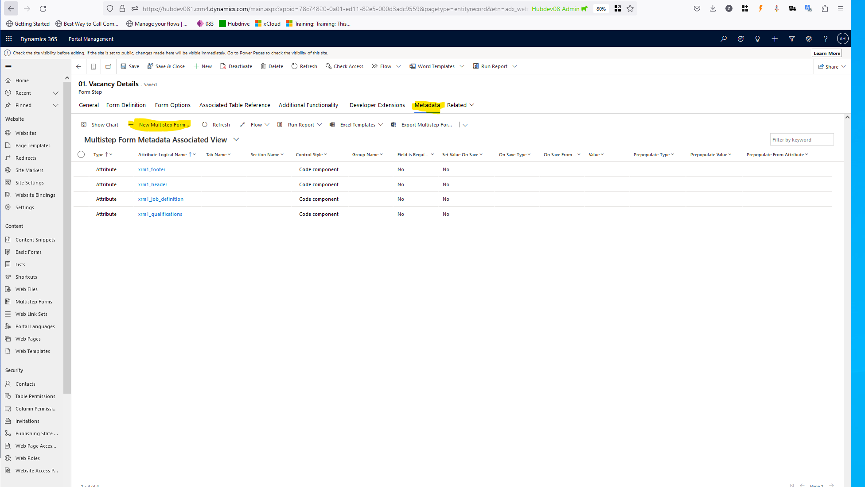

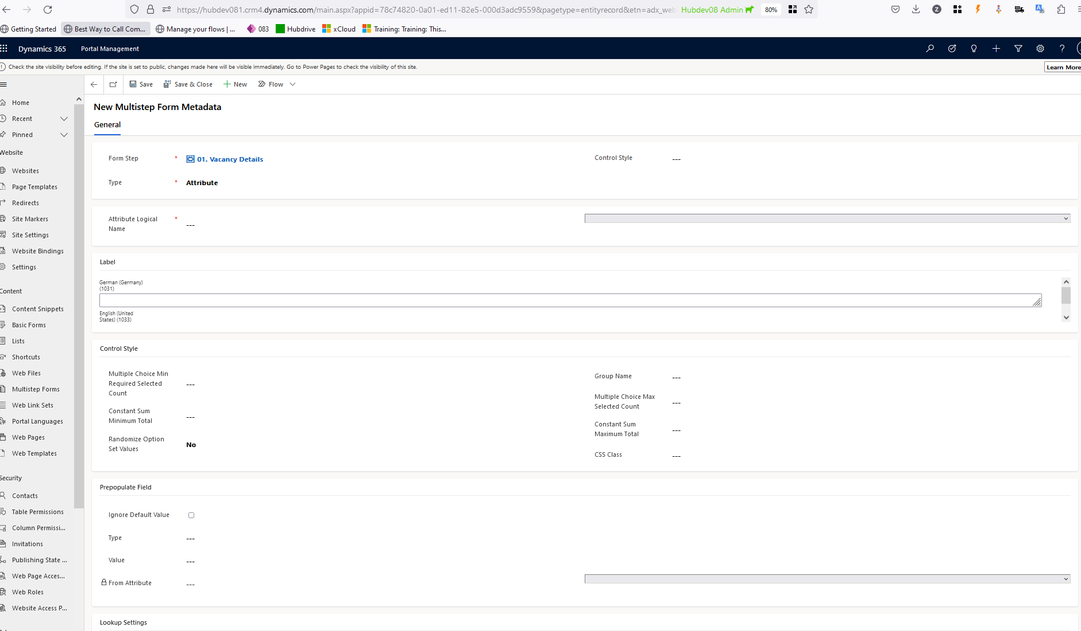

5 - Add the following meta data records :

Record 1 -
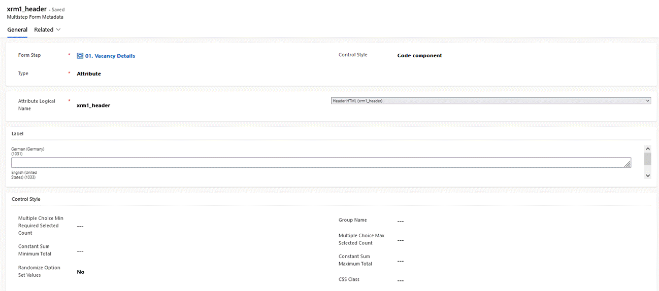

Record 2 -
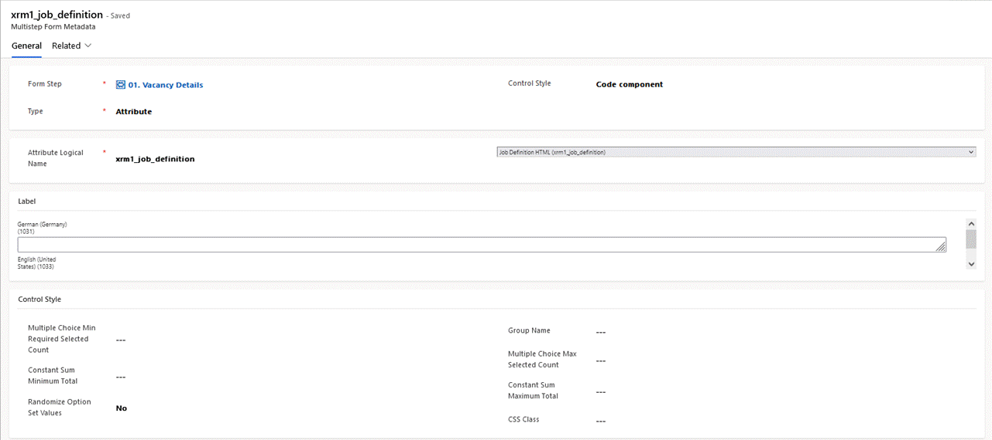

Record 3 -

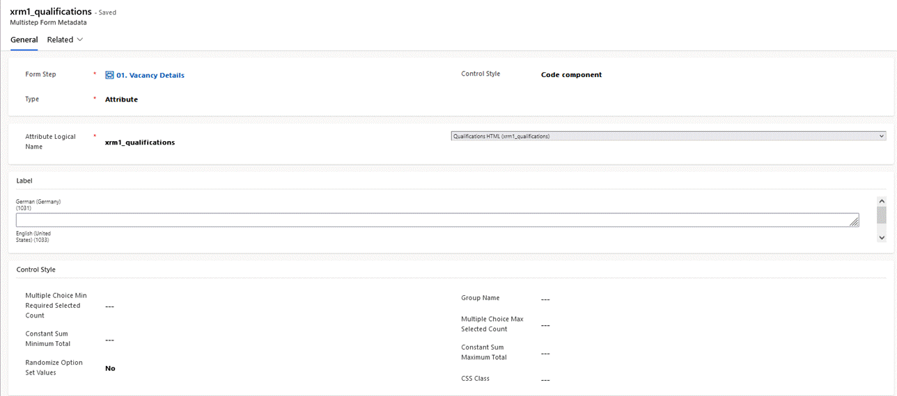

Record 4 -

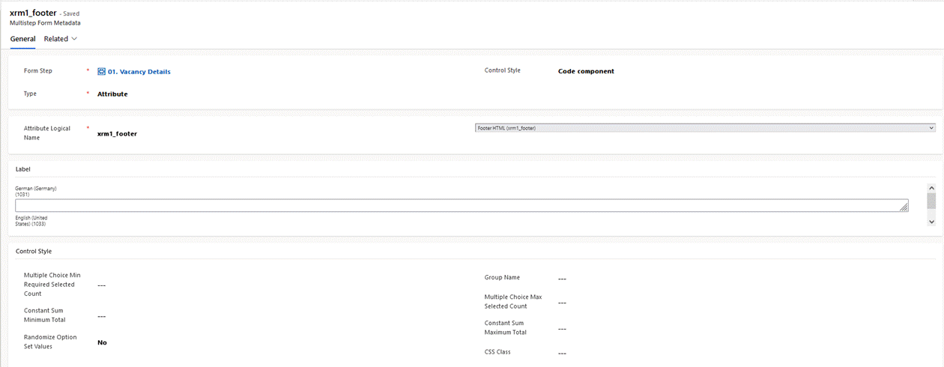

End Result after adding all the records -

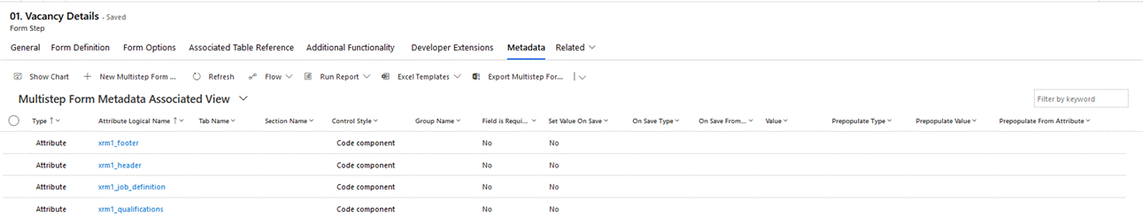

Next..Add two site settings:

In portal management app, go to Site Settings from the left hand navigation menu and click "New"

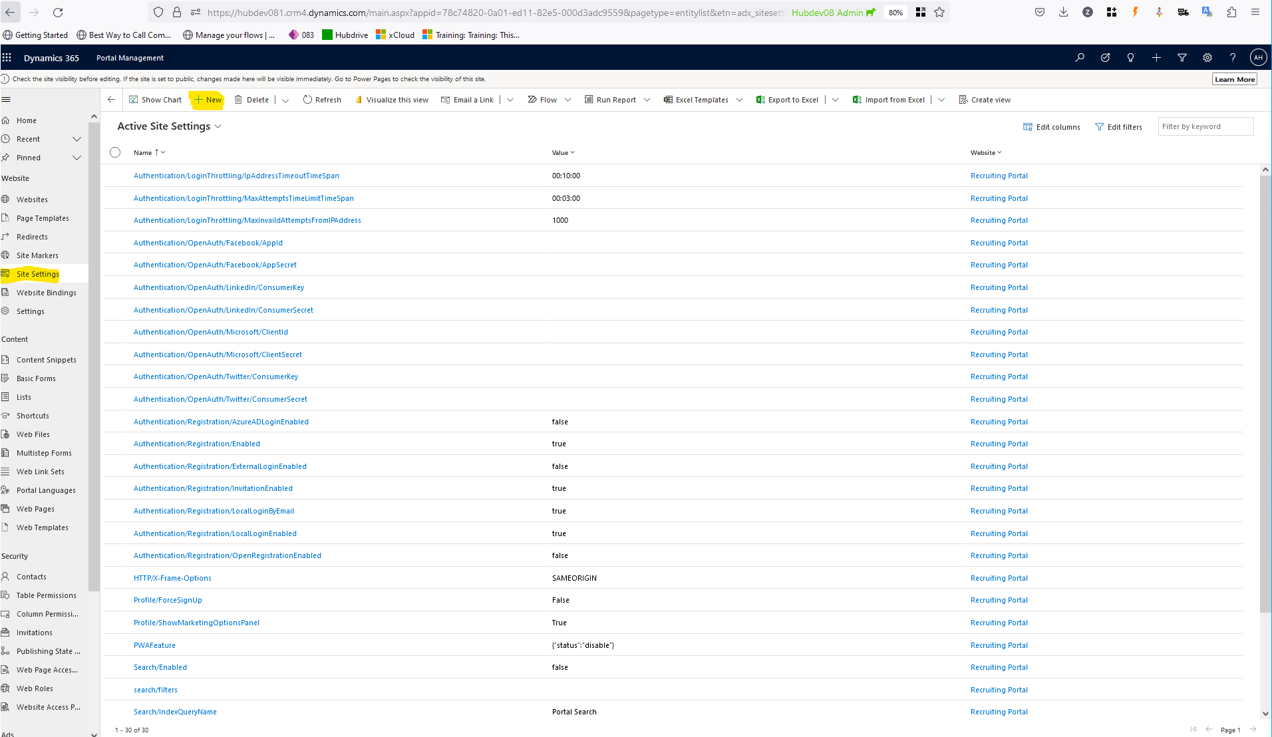

Records 1 -

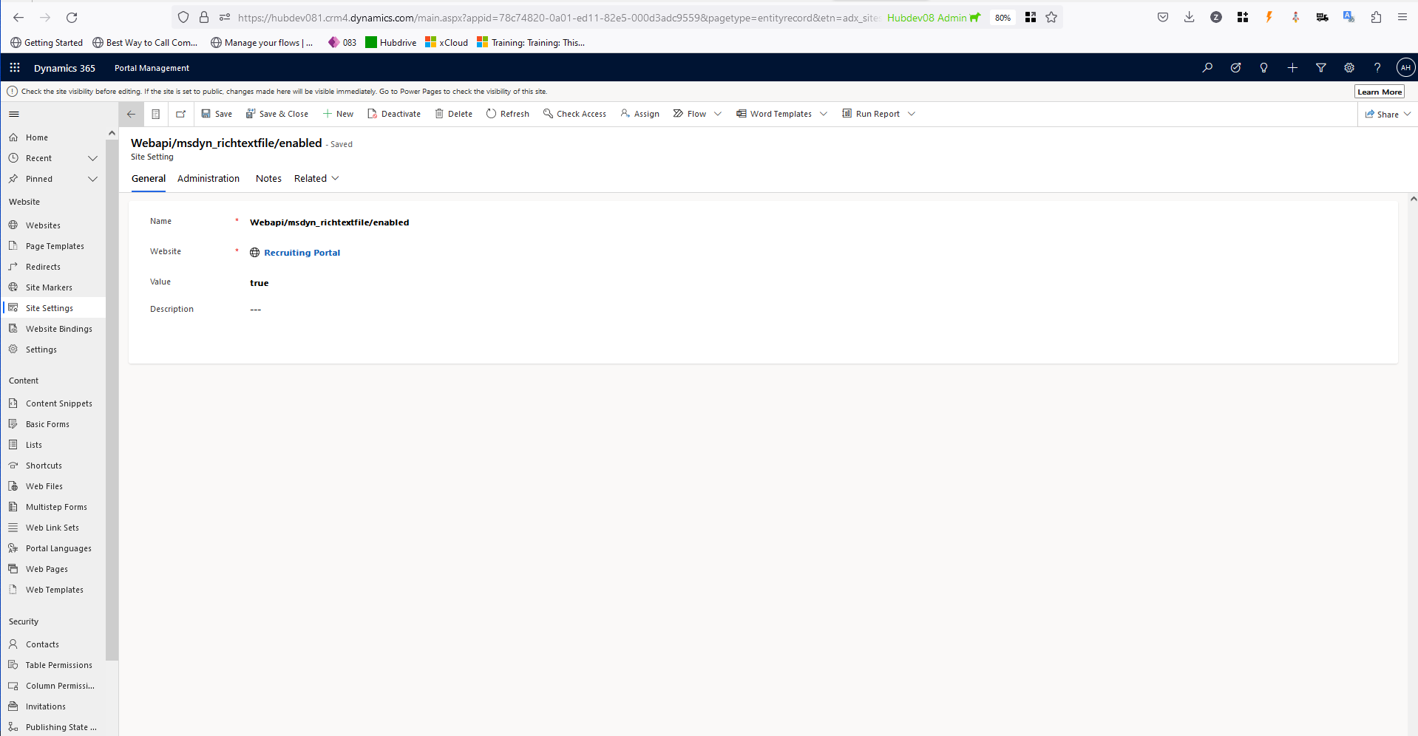

Record 2 -

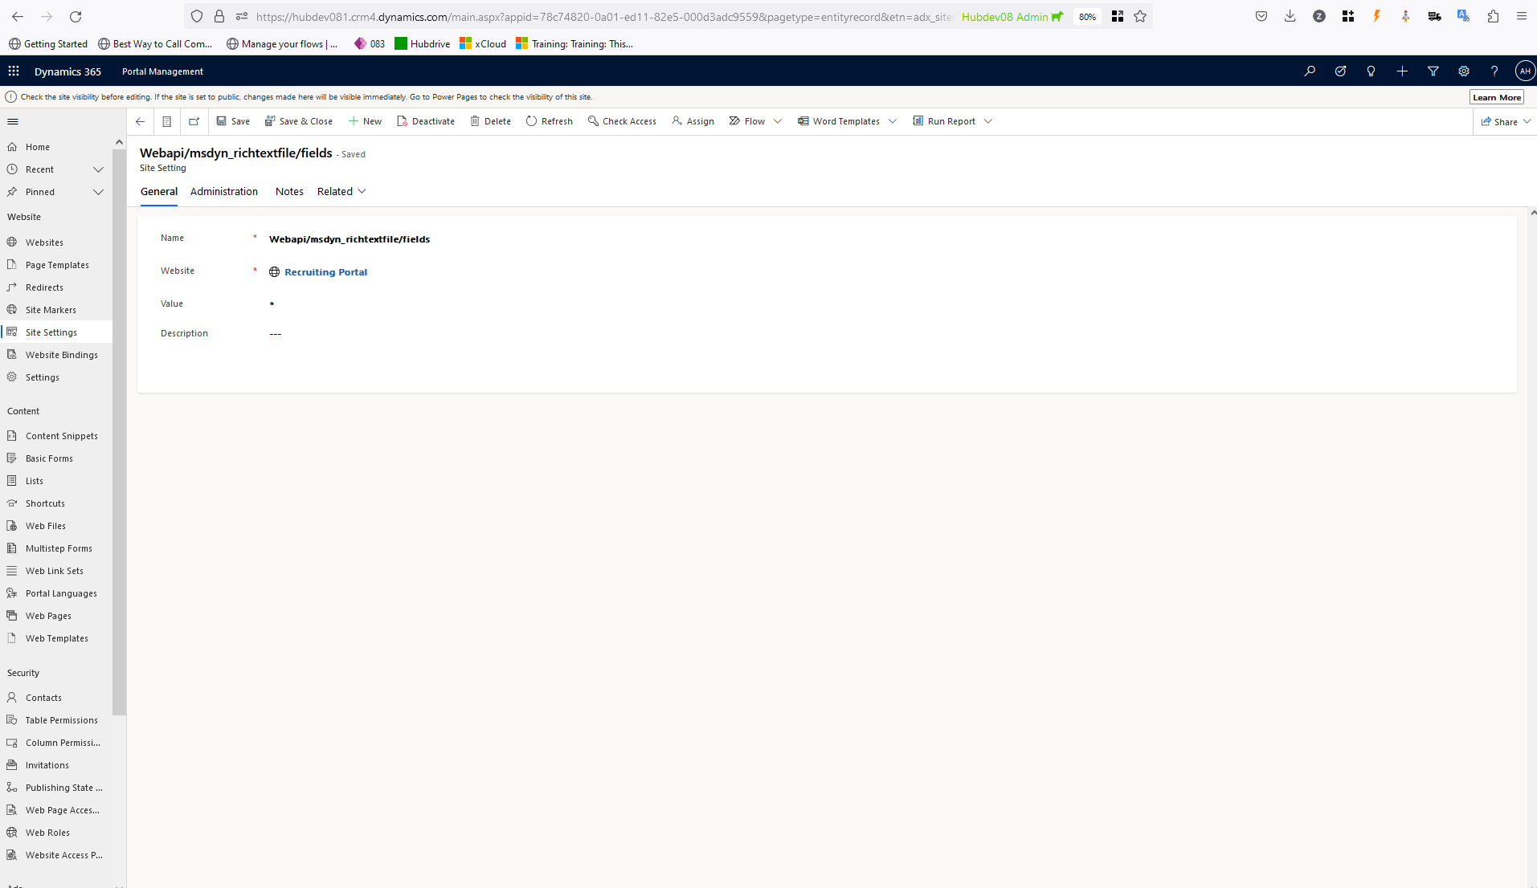

End Result -

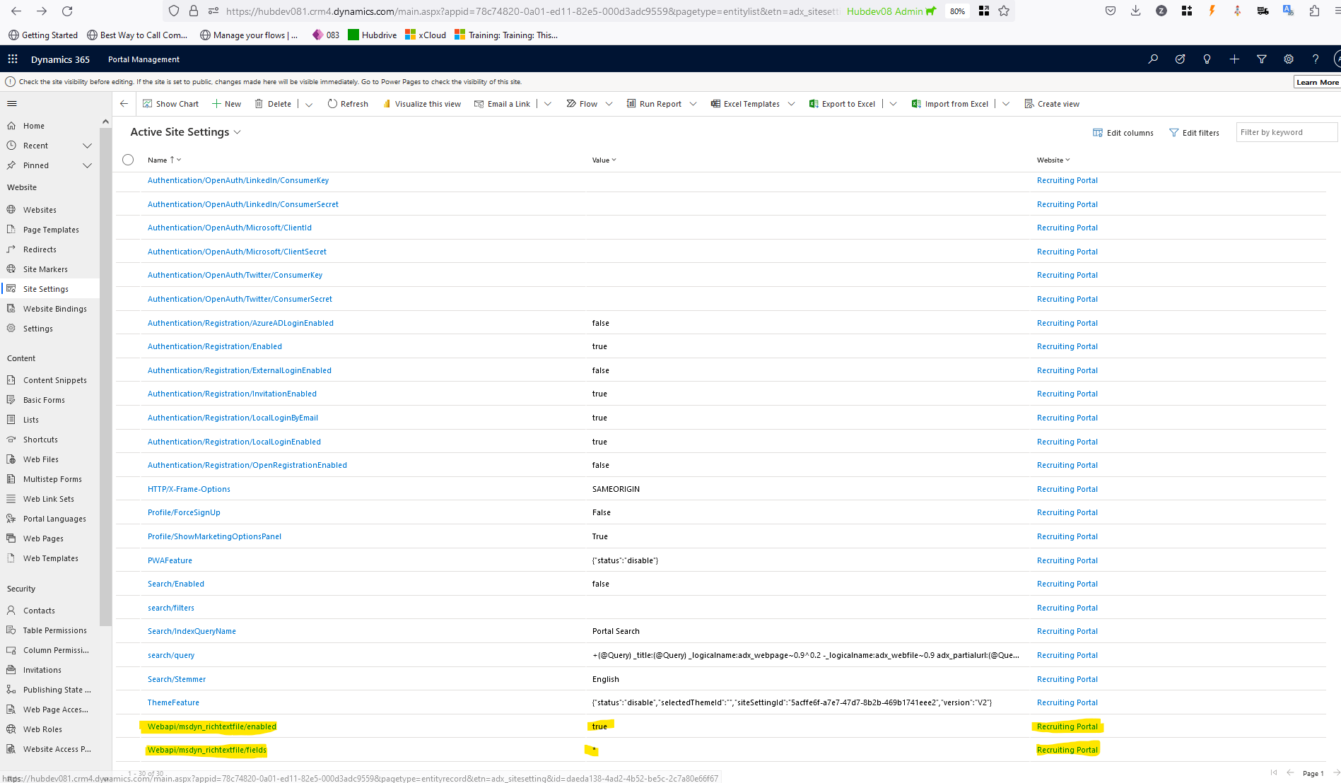

The next step is to make some minor adjustments in Javascript file. For doing so

1 - Go to "Web Templates" in the navigation menu on the left
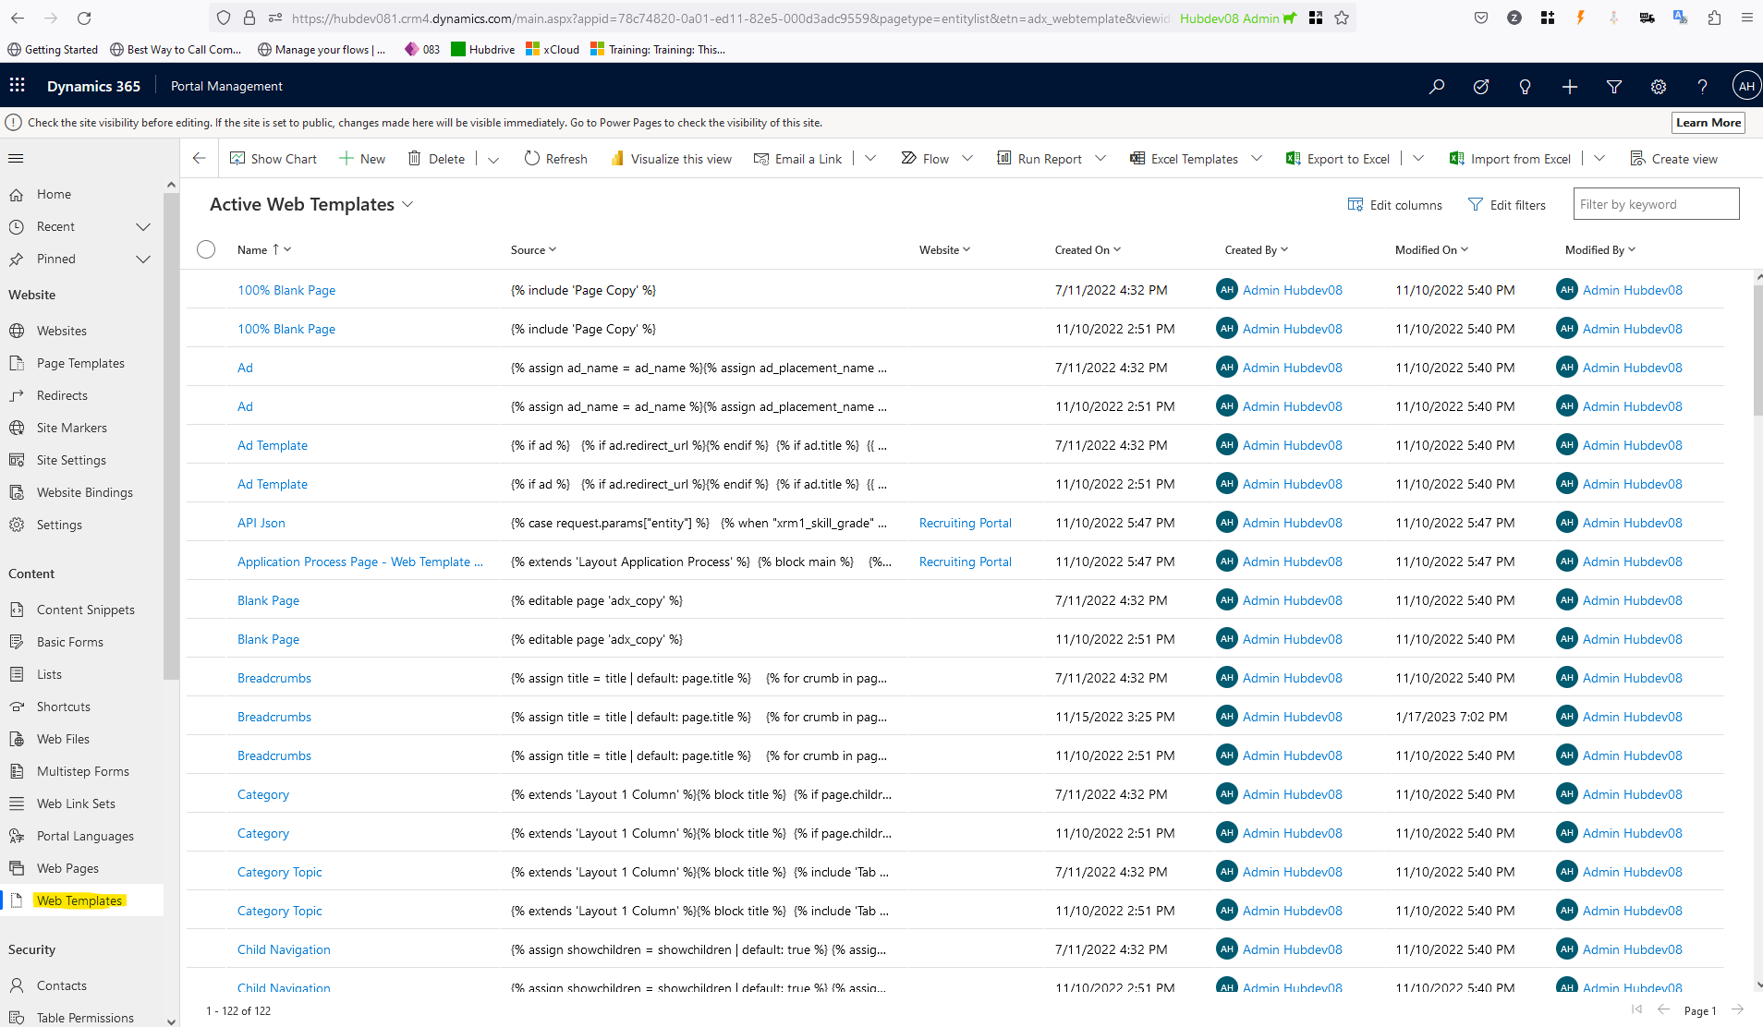

- Search for "Website.JS"

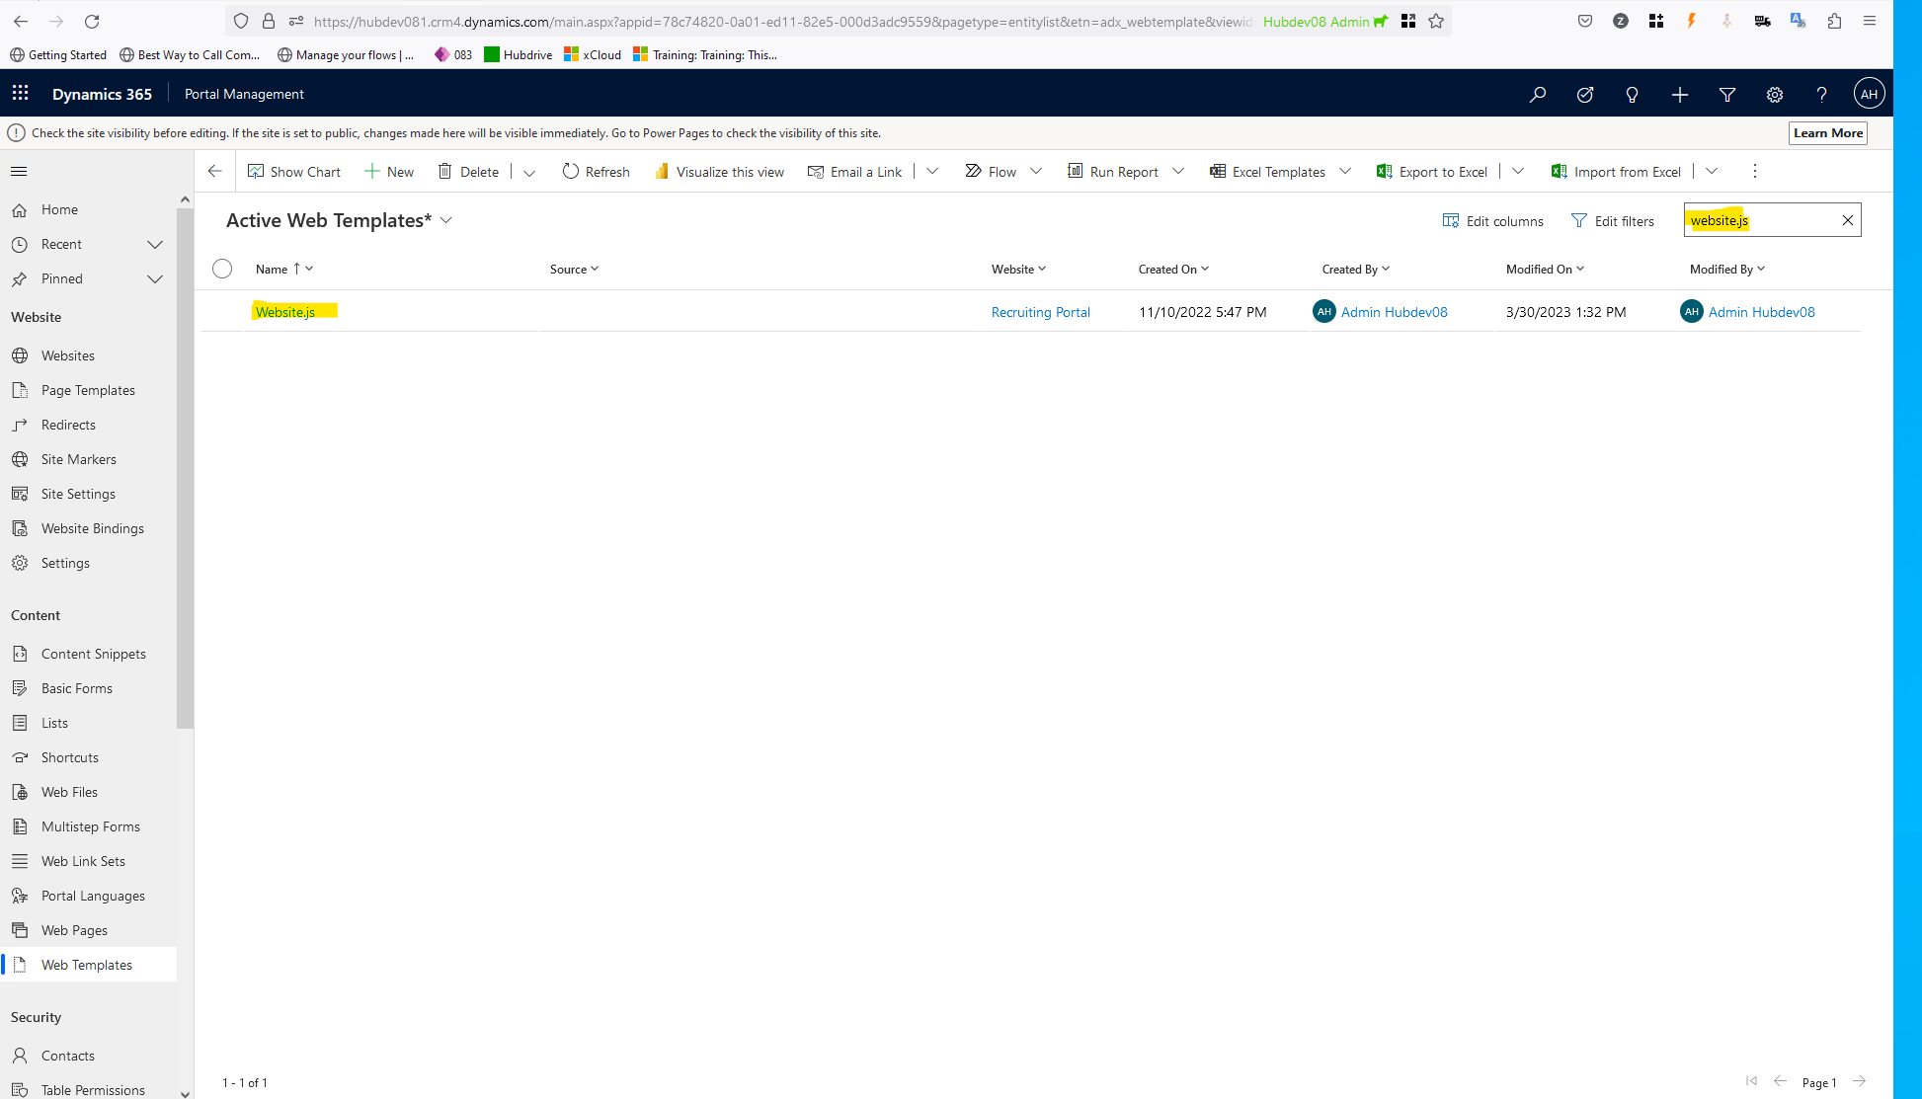

- open the website.JS record

- Change in code with following details:

Find this line :

RecruitingPortals.prototype.VacancyDetailsTranslations = function (vacancyId) {

And Paste this code just before that line :

RecruitingPortals.prototype.waitForTranslationToLoad = function () {};

End result should look like this:
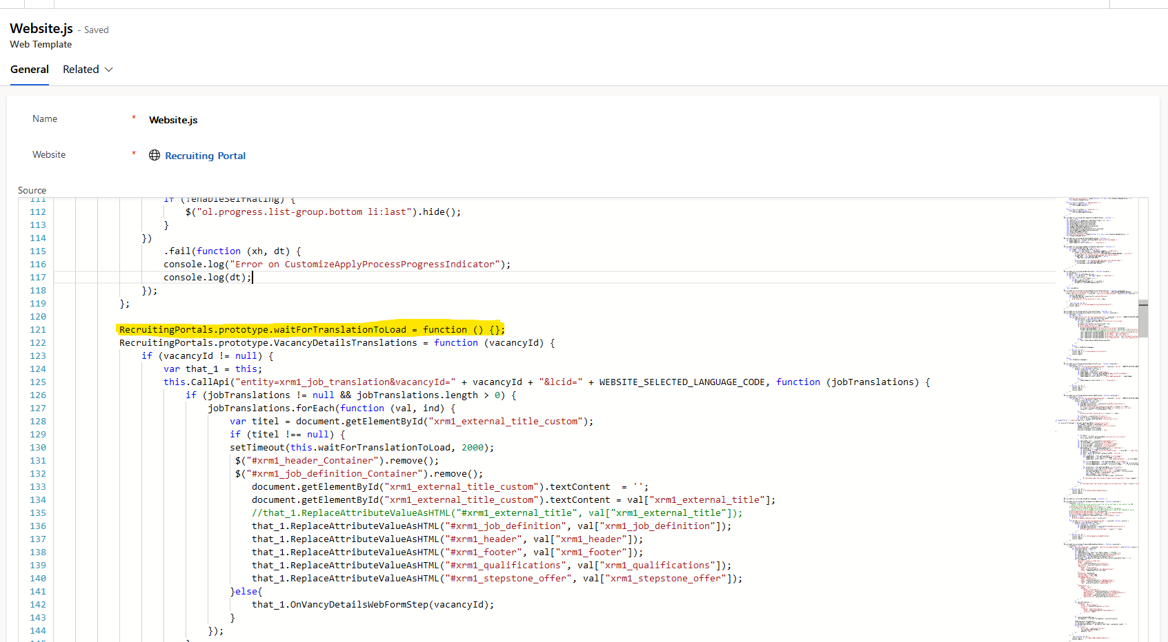

Next, find this line:

if (titel !== null) {

And paste directly after that line:

setTimeout(this.waitForTranslationToLoad, 2000);
$("#xrm1_header_Container").remove();
$("#xrm1_job_definition_Container").remove();

End result should look like this:

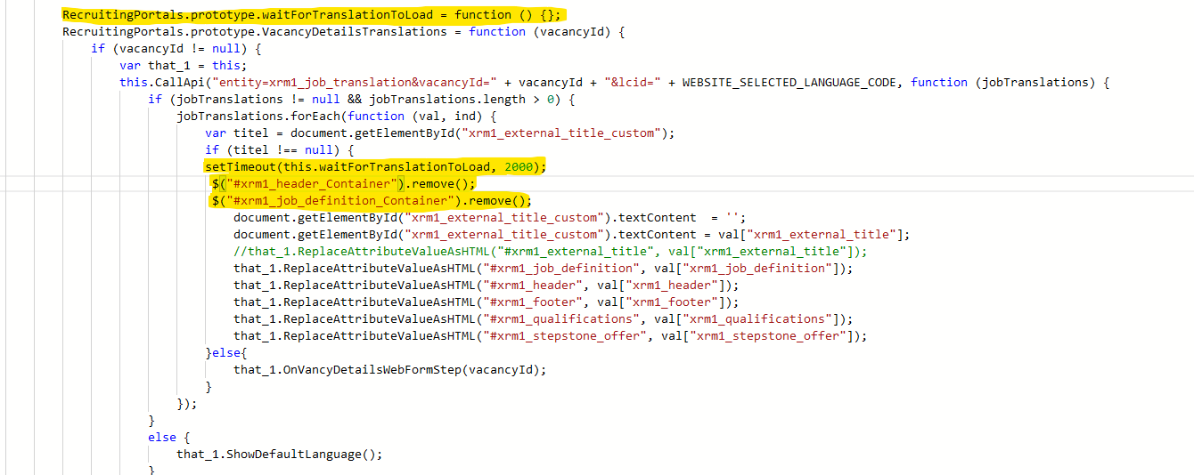

Next find this block of code:

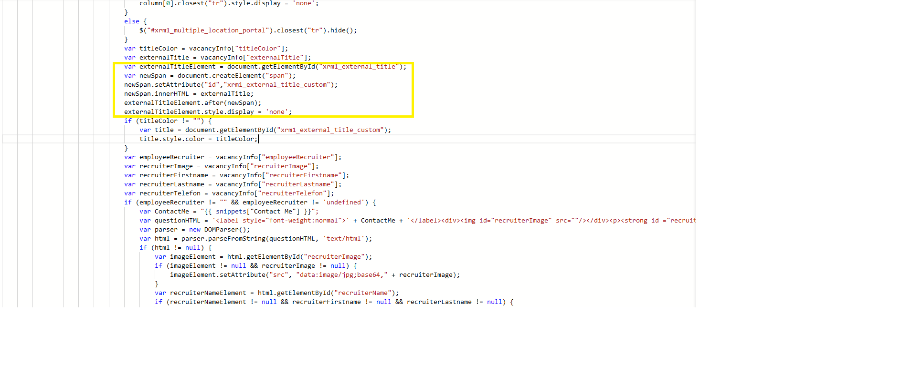

var externalTitleElement = document.getElementById("xrm1_external_title");
var newSpan = document.createElement("span");
newSpan.setAttribute("id","xrm1_external_title_custom");
newSpan.innerHTML = externalTitle;
externalTitleElement.after(newSpan);
externalTitleElement.style.display = 'none';

Replace it with this:
if (typeof(title) != 'undefined' && title != null)
{
var externalTitleElement = document.getElementById("xrm1_external_title");
var newSpan = document.createElement("span");
newSpan.setAttribute("id","xrm1_external_title_custom");
newSpan.innerHTML = externalTitle;
externalTitleElement.after(newSpan);
externalTitleElement.style.display = 'none';
}

End result should look like this:

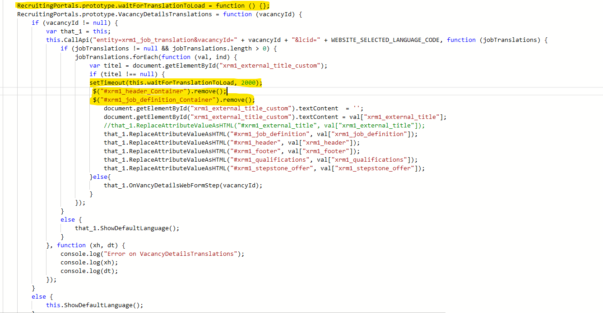

Next Find this piece of code

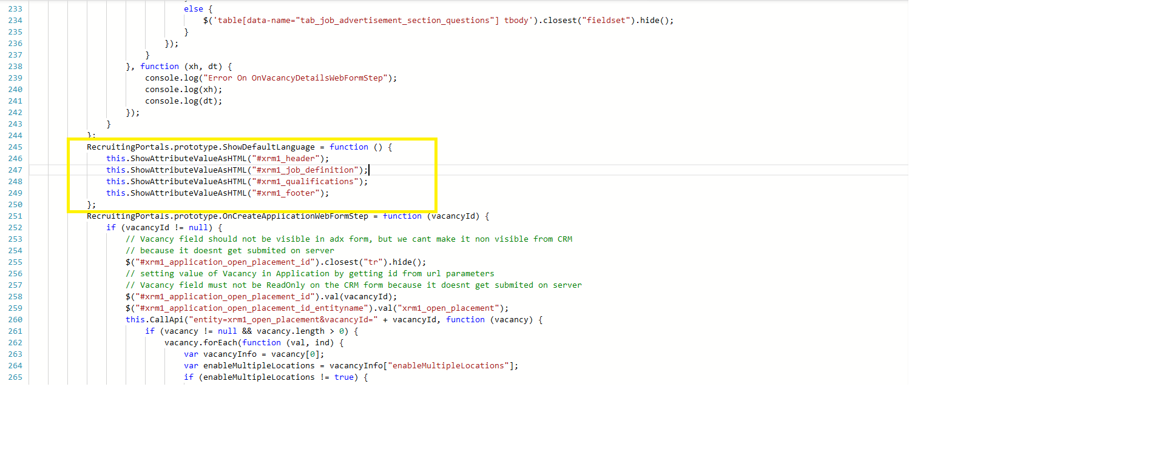

Remove/delete these lines

this.ShowAttributeValueAsHTML("#xrm1_header");
this.ShowAttributeValueAsHTML("#xrm1_job_definition");
this.ShowAttributeValueAsHTML("#xrm1_qualifications");
this.ShowAttributeValueAsHTML("#xrm1_footer");
this.ShowAttributeValueAsHTML("#xrm1_stepstone_offer");

Done

